
CENTRAL BANK OF CYPRUS
Accessing the FTP Server - User Manual
IT Department, CENTRAL BANK OF CYPRUS

Table Of Contents
1 Executive Summary 1
1.1 Audience 1
1.2 Scope 1
2 Accessing FTP Server 2
3 Service Accessibility 3
4 Limits/Settings 4
5 Accessing the CBC FTP Server For the First Time 5
6 Accessing the CBC FTP Server 7
6.1 Connecting with a Web Client 7
6.1.1 How To Login 7
6.1.2 How To Upload A File 8
6.1.3 How To Download a file 9
6.1.4 How To Rename a file 10
6.1.5 How To Delete a file 11
6.1.6 How To Browse Between Directories 12
6.1.7 How To Change Email Address 12
6.1.8 How To Recover Password 13
6.1.9 How To Logout 14
6.2 Connecting with an SFTP Client 15
6.2.1 Setting UP A Connection In The SFTP Client (FileZilla is used as an example) 15
6.2.2 How to Login 17
6.2.3 How to Upload a file 18
6.2.4 How to Download a file 19
6.2.5 How to Logout 19

- Executive Summary
This document provides instructions on how to connect to the FTP server.

Audience
CBC External Users

Scope
The scope of this document is to help the CBC External Users to connect to the FTP server using the protocols https and SFTP.
- Accessing FTP Server
You can access the FTP server in one of the following ways:
  - Web Browser – Login to the FTP server using https, using the preferable web browser (e.g. latest version of Internet Explorer)
  - FTP Client – Login to the FTP server using SFTP (port 22), using the preferable FTP client (e.g. latest version of Filezilla)
Important note: Web browsers and FTP clients need to support at least TLS 1.2 protocol (TLS 1.0, TLS 1.1, SSL 2.0 and SSL 3.0 are not supported)
- Service Accessibility

The Remote FTP access service is made available by the Central Bank of Cyprus strictly to authorized external parties only.

- Limits/Settings
The password must contain 10 characters minimum, of which at least one uppercase, at least one lowercase, at least one number and at least one non-alphanumeric character.
The password has a maximum lifetime of 220 days.
The maximum number of sessions for each user is 10.
The connection timeout is set to 120 minutes and the IDLE connection time out is set to 10 minutes.

- Accessing the CBC FTP Server For the First Time
The first time a user accesses the FTP Server, he must be doing so through the web browser (e.g. Internet Explorer). This is so because the first time the user logins, he will be asked to change his password. This can only be done by the FTP server web client.

The user must open an Internet Explorer and type in the server’s address:

https://ft.centralbank.cy

The user must then type in his credentials and click “Login”.

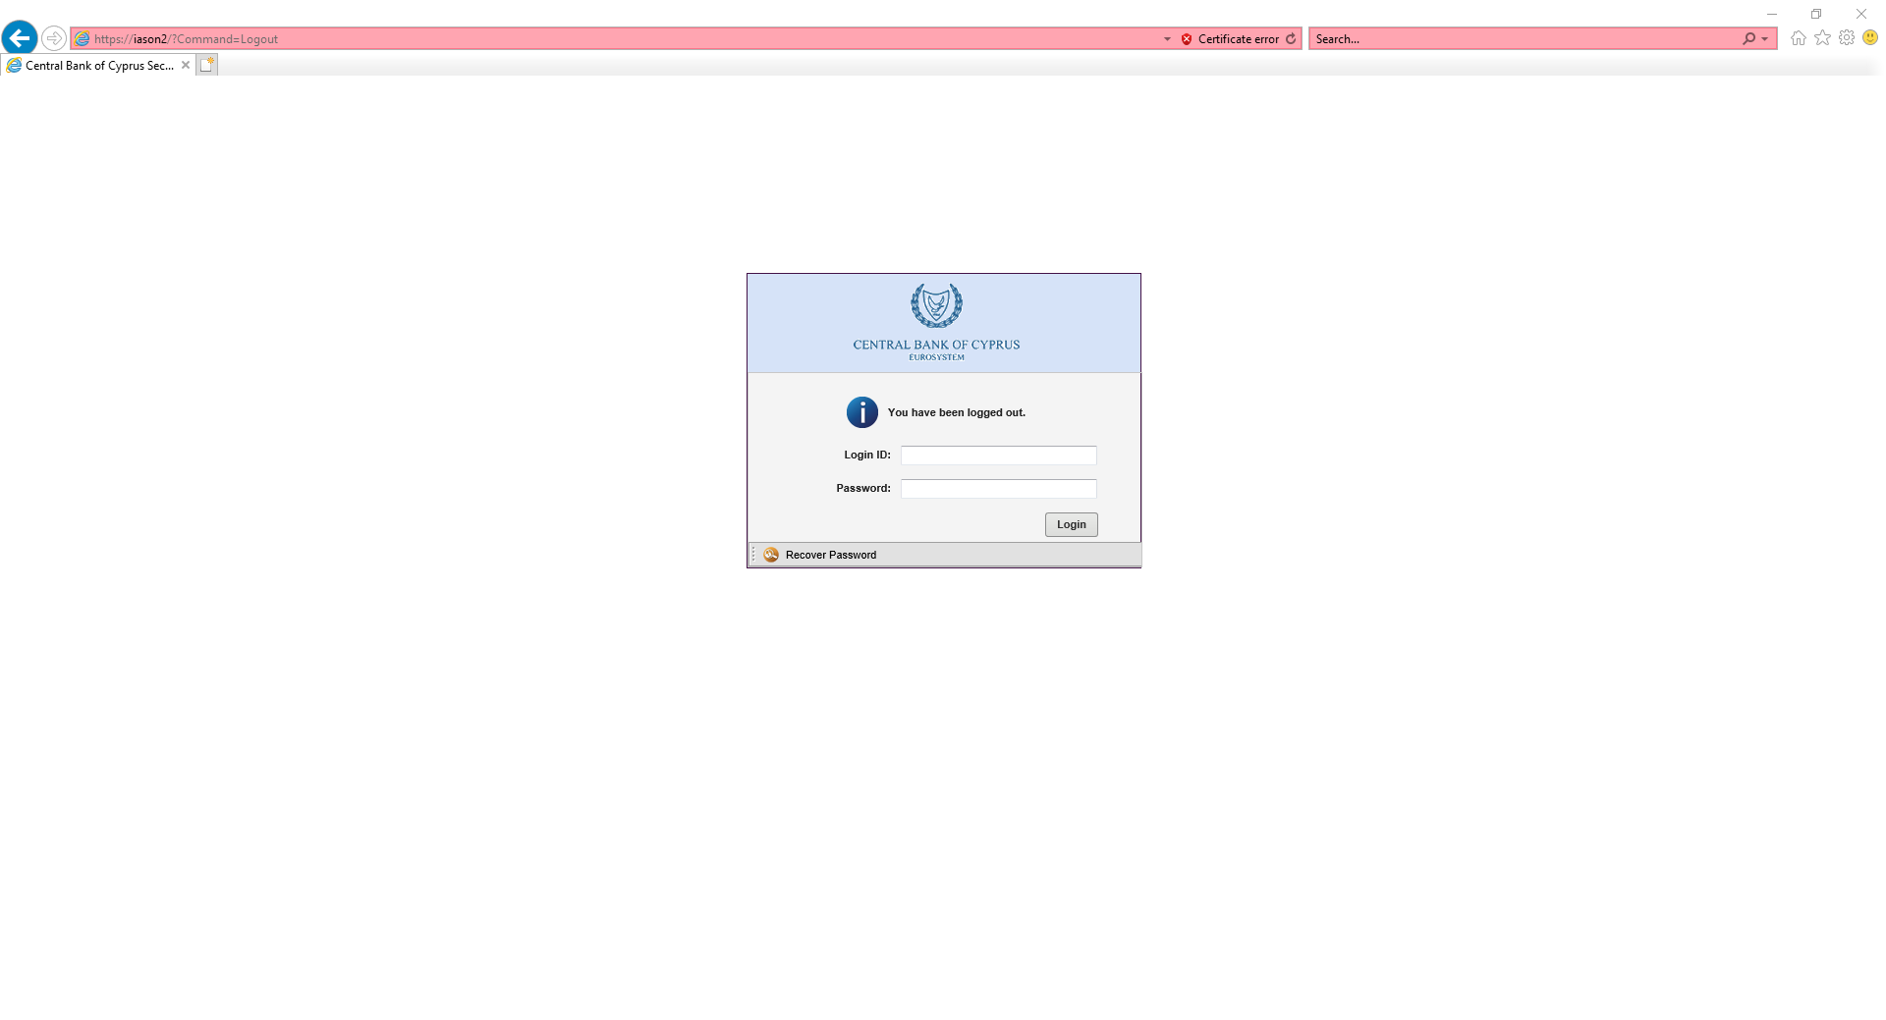
At the pop up window the user must type in the password provided by CBC and then enter a new password twice. He must then click “OK”.

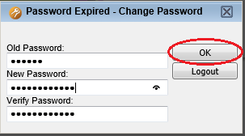

Every time the user’s password expires, the same pop up window will appear and ask the users to change their password.

To manually change the password, the user must click on the arrow at the top right of the screen and select “Change Password”.

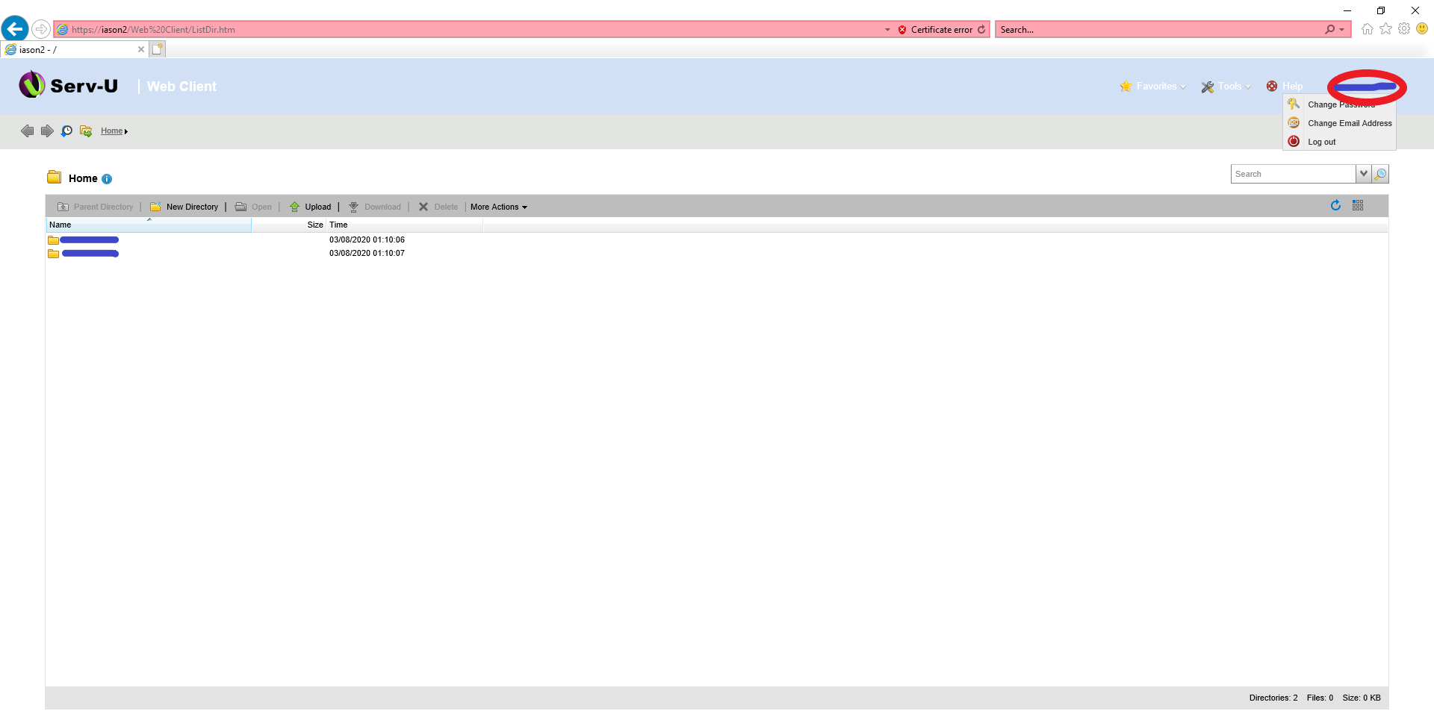
- Accessing the CBC FTP Server

Connecting with a Web Client

How To Login

The user must open an Internet Explorer and type in the server’s address:

https://ft.centralbank.cy

The user must then type in his credentials and click “Login”.

How To Upload A File

To upload a file the user must click “Upload”.

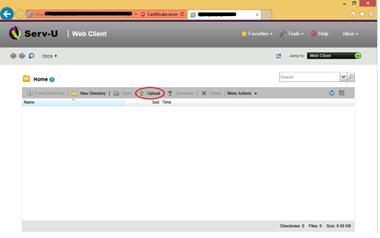

The user must click “Browse…” to point to the file he wants to upload.

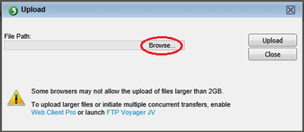

The user must choose the file he wants to upload and click “Upload”.

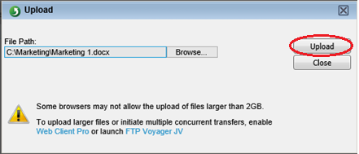

As soon as the upload finishes he must click “Close”.

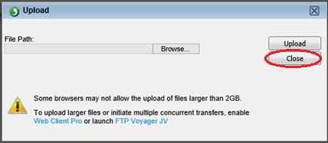

How To Download a file

To download a file from the FTP server, the user must select the file he wants to download and Click “Download”.

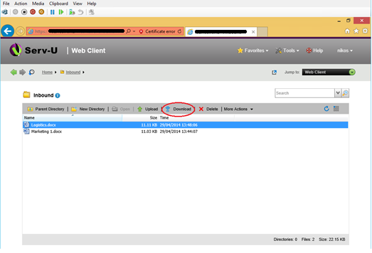

On the Internet Explorer prompt the user must click “Save As” and choose the folder where he wants the selected file to be downloaded.

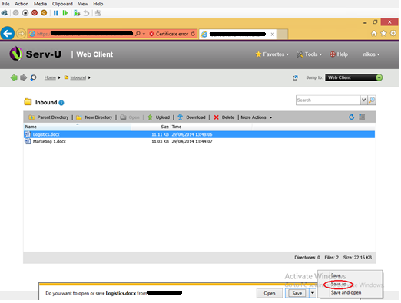

How To Rename a file

To rename a file stored on the FTP Server, the user must choose the file and click “More Actions”, “Rename”.

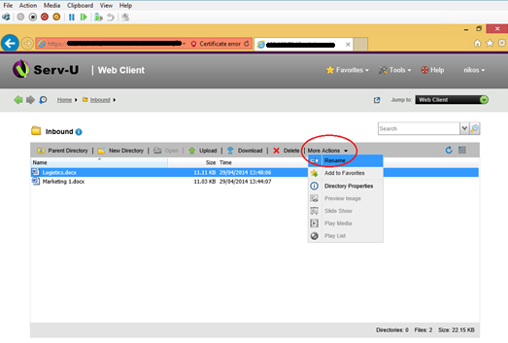

Rename the file and select OK

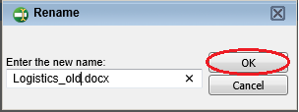

How To Delete a file

To delete a file, the user must select the file and click “Delete”.

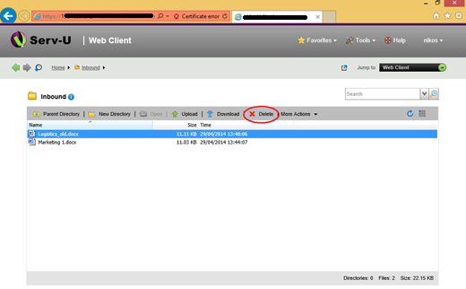

On the pop up window Click “Yes”.

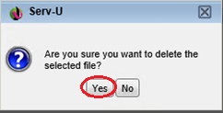

How To Browse Between Directories

If the user is in a directory and wants to browse up one level, he must click “Parent Directory”.

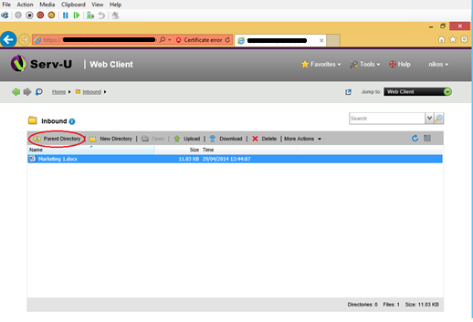

How To Change Email Address
To change the email address connected to the respective account, the user must click at the top right of the screen and click “Change Email Address”

Then the user will be prompted to enter the new Email address twice (in the fields “Email Address” and “Verify Email Address” and press OK button:
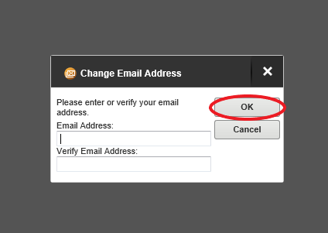

How To Recover Password
In case of password recovery is needed (i.e. User lost password and needs new one) user can press “Recover Password” button in login screen:

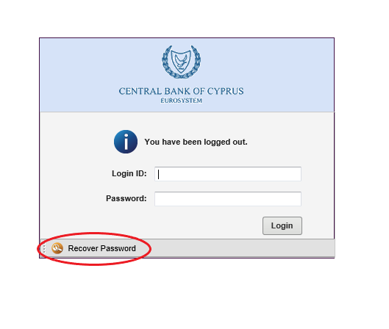
Then the user will be prompted to enter its Login ID and press OK
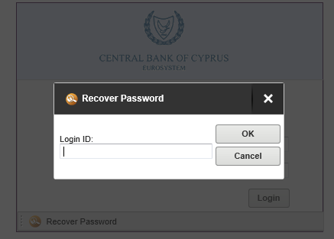

If the entered Login ID exists and is linked to an Email Address (see 6.1.7) an automated Email will be send to the respective Email Address with the new Password. It is recommended for the User to change that auto-generated password (see 5), based on Password Limits/Settings (see 4)

How To Logout

To logout from the portal, the user must click on the arrow at the top right of the screen and click “Logout”.

Connecting with an SFTP Client

In order for users to be able to connect through SFTP, an FTP client (e.g. FileZilla) must be set up with the FTP Server internet address (ft.centralbank.cy) using SFTP protocol (port 22). After set up the user can connect to the FTP server using his Login ID and password.

Note1: The first time the users try to connect to the FTP Server, they must use the Web Client in order to be able to change their password (See Section 4: Accessing the CBC FTP Server for the first time).

Note2: Every time the users’ password expires, they must change it though the Web Client (See Section 4: Accessing the CBC FTP Server for the first time).

Setting UP A Connection In The SFTP Client (FileZilla is used as an example)

The user must click File and select Site Manager.

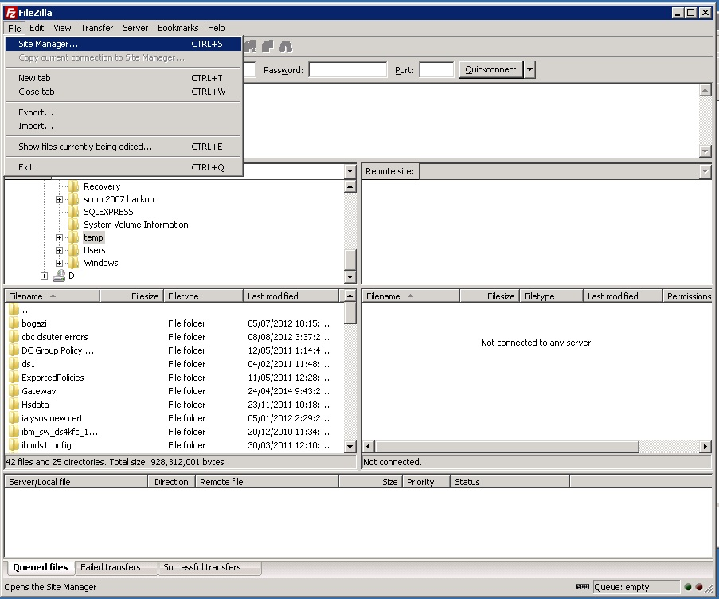

The user must click “New Site”

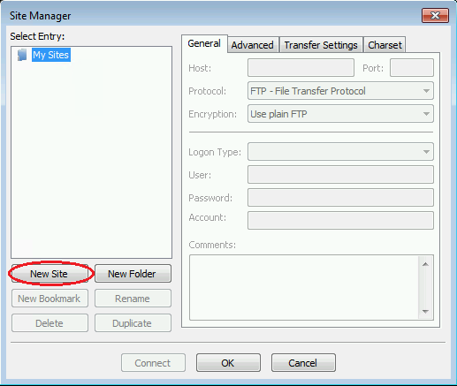

The user must type in the name of the connection (e.g. CBC FTP gateways). In the “Host” box the user must type in the FTP Server internet address (ft.centralbank.cy). In the “Port” box the user must type in 22 and from the “Protocol” dropdown list the user must select SFTP- SSH File Transfer Protocol. From the “Logon Type” dropdown list the user must select Ask for password. In the “User” field the user must type in the username provided by CBC. The user must click on “OK” after filling the required fields.

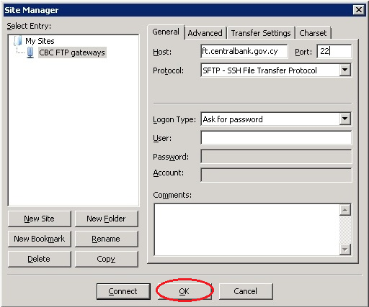

How to Login

The user must click File and select Site Manager.

In the Site Manager page the user must click “Connect”.

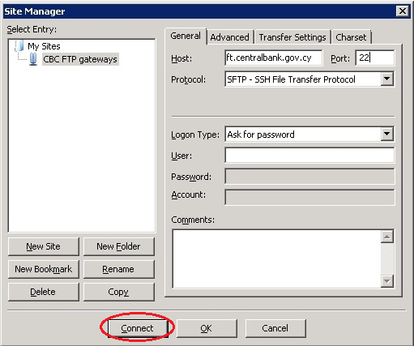

In the prompt for password, the user must type in his password and click “OK”.

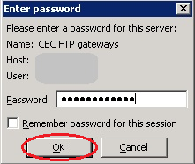

If the user needs to change his password (either his password has expired or it’s the first time he connects to the FTP server) he will receive the following error:

In such a case the user must use the web browser to change his password (See Section 4: Accessing the CBC FTP Server for the first time).

How to Upload a file

To upload a file the user must right click the desired file and select “Upload”.

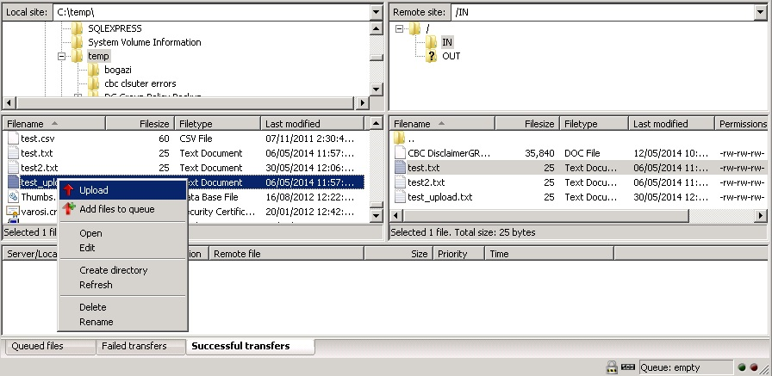

How to Download a file

To download a file the user must right click the desired file and select “Download”.

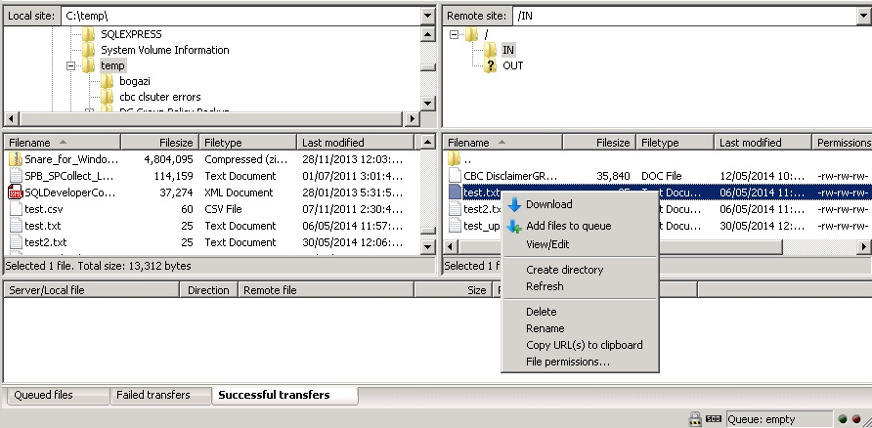

How to Logout

To logout, the user must click on the button “Disconnects from the currently visible server”.

